SkillsCertify.org - Online Skill Certification Platform
Shyam is a graduate who dreams of building his career in the Human Resources domain. However, due to limited job opportunities in the market, Shyam accepted a job as a Process Executive in a company. Although he is working hard, the job is not related to his interest in HR. After a few months, Shyam becomes dissatisfied and starts searching again for HR opportunities.
Because of this situation, the company that hired Shyam loses the time, effort, and money spent on training him. At the same time, Shyam also loses valuable time in his career because the job he accepted did not help him grow in the field he wanted. This type of problem is happening in many organizations where candidates accept any available job instead of roles aligned with their interests and skills. As a result, companies experience frequent employee turnover, and candidates struggle to build the right career path.
After observing this issue, the management team at APT IT Solutions decided to find a solution that could help both companies and candidates. Mr. Ram, the CEO of APT IT Solutions, discussed this problem with his colleagues Mr. Ravi, who is the Financial Head, and Ms. Latha, who is the Project Coordinator. Together, they realized that the main problem is that companies hire candidates without knowing whether the candidates truly have the required skills or a real interest in the role.
To solve this problem, APT IT Solutions decided to develop an online platform called SkillsCertify.org. Through the SkillsCertify.org web and mobile application, candidates can select their desired domain — such as Human Resources, Business Analysis, Software Development, or Marketing — and take rolebased certification exams designed by Subject Matter Experts (SMEs).
Companies such as Tech Mind Solutions and Zillion Technology can partner with SkillsCertify.org and endorse these certification exams. When candidates successfully pass these exams, their verified profiles will be stored in the SkillsCertify.org database. Partner companies can then access this database and identify candidates who are already certified and interested in specific roles. APT IT Solutions has decided to develop this platform with a budget of Rs. 1.5 Crores and a duration of 18 months. Mr. Raju is the Delivery Head and Mr. Krishna is the Project Manager.

Your Project Team:

Role | Name
Project Manager | Mr. Krishna
Senior Java Developer | Ms. Juli
Java Developers | Mr. Chris, Mr. William, Mr. David, Mr. John
Network Administrator | Mr. Daniel
Database Administrator | Mr. Steve
Testers | Mr. Peter, Ms. James
Business Analyst | You

To gather business requirements from the client, you met Mr. Ram (CEO) at APT IT Solutions. Mr. Ram (CEO) stated that he expects the platform to have a login/registration system for all users (Candidates, SMEs, and Partner Companies), a domain selection feature, a certification exam module, a candidate profile and dashboard, and a company portal to search for certified candidates.
After doing the stakeholder analysis, you identified that Shyam (representing candidates), the SMEs, and the HR managers from partner companies like Tech Mind Solutions are the key stakeholders. Upon meeting them: Shyam said that candidates should be able to browse available certification exams by domain without logging in, and should need to log in only when registering for an exam. The SME representative said that SMEs should have a dedicated portal to create, edit, and publish exams with multiple question types. The HR Manager from Tech Mind Solutions said that partner companies should be able to search the certified candidate database by domain, skill level, and certification score, and should receive notifications when new candidates are certified in their required.

Identify Business Requirements (which includes Stakeholder Requirements):
BR001 – Candidates should be able to browse and search for available certification exams by domain on SkillsCertify.org.
BR002 – SMEs should be able to create, upload, and manage role-based certification exams on the platform.

Question 1 Audit:- 5 Marks
4 Quarterly Audits are planned (Q1, Q2, Q3, Q4) for the SkillsCertify.org project.
What is your knowledge on how these Audits will happen for a BA?
Explain the purpose, process, and what a BA is expected to prepare and present during each quarterly audit.
Answer 1:
Purpose: Quarterly audits ensure the project is on track, requirements are aligned, and deliverables meet expectations.

Process:
Stage | Quarter 1 (Audit Report)
Phase | Requirement Gathering Phase
Timeframe | 10 Weeks (Week 1 to Week 10)
Check List | BA will done stakeholder analysis
 | BA will completed elicitation process and prepare notes
 | BA will Validate / Prioritize Requirement
 | BA will prepare Business Requirement Document (BRD), Functional Requirment Document (FRD)
 | BA will group all the functionalities and features.

Stage | Quarter 2 (Audit Report)
Phase | Requirement Analysis Phase
Timeframe | 08 Weeks (Week 13 to Week 20)
Check List | BA will show finalize requirement and prepare UML Diagrams
 | BA will prepare use cases and models
 | BA will prepare RTM document

Stage | Quarter 3 (Audit Report)
Phase | Development Phase
Timeframe | 10 Weeks (Week 21 to Week 30)
Check List | BA collaborate with Development Team
 | BA align with technical team
 | BA align with stakeholder
 | BA identify the Risk and mitigate the risk

Stage | Quarter 4 (Audit Report)
Phase | UAT (User Acceptance Testing), Audit Phase
Timeframe | 08 Weeks (Week 31 to Week 38)
Check List | BA presents UAT result, handle change requests and test cases
 | BA presents client acceptance form
 | BA presents closure documents
 | BA completes BRD, FRD and email the functionalities and get sign off

BA Preparation:
- BRD, SRS, Use Case Diagrams, Requirement Traceability Matrix (RTM), Change Request Log, UAT sign-off.

Question 2 – BA Approach Strategy 6 Marks
Before the SkillsCertify.org project kicked off, the committee of Mr. Ram (CEO), Mr. Ravi (Financial Head), and Ms. Latha (Project Coordinator) asked Mr. Raju (Delivery Head) to submit a BA Approach Strategy.
Write the BA Approach Strategy covering: What Elicitation Techniques to apply, how to do Stakeholder Analysis (RACI/ILS), What Documents to Write, What process to follow to Sign off on Documents, How to take Approvals from the Client, What Communication Channels to establish and implement, How to Handle Change Requests, How to update the progress of the project to Stakeholders, and How to take sign-off on the UAT – Client Project Acceptance Form.

Answer 2:
What Elicitation Techniques to apply:
There are many elicitation techniques to apply used to gather requirements.
- Interviews- It is a systematic approach to gather the requirements.
- Workshops- It is the structured approach to gather the requirements.
- Prototyping- It is the most useful requirement gathering process for complicated systems.
- Document analysis- It is done through reading a document and understanding the product.
How to do Stakeholder Analysis RACI:
We need to identify Stakeholder and defining their roles and responsibilities.
RACI (Responsible, Accountable, Consulted, Informed) + ILS (Influence, Legitimacy, Support).
Stakeholder | Role
CEO (Mr. Ram) | Accountable/Consulted
Financial Head (Mr. Ravi) | Accountable/Consulted
Project Coordinator (Ms. Latha) | Responsible
Delivery Head (Mr. Raju) | Responsible
Project Manager (Mr. Krishna) | Accountable
Business Analyst | Responsible/Consulted
Developers/Testers/DBA/Network Admin | Informed
Candidates (Shyam) | Informed/Consulted

What Document to Write:
BRD- It captures high level business needs, objective and stakeholder expectation.
SRS- It provide complete functionality and non-functionality details.
Use Case Specs- It will share the user interaction details with the system.
RTM- It validated all the requirement are implemented or not.
UAT Acceptance Form- This process confirm that the delivered system meets business needs.
Sign-off Process:
Firstly, we circulate draft document (BRD, SRS, Use Case, etc. with all the relevant stakeholders.
Conduct meetings/workshops to discuss feedback (Present the revised document, if required)
Client approved all the requirements/documents and obtain official (email) confirmation.
Communication Channels:
There are many channels to communicate with stakeholders but it should be in written form.
It can be Email, project portal, weekly meetings, dashboards. etc.
Change Requests:
All the change request should be Logged in CR register and in impact analysis so that these changes can be added in approval workflow.
Progress Updates:
Progress report should be communicated in Project. It can be done in Weekly reports, 2 week review meeting, dashboards, stakeholder meetings, etc.
UAT Sign-off:
Firstly, Client validates UAT, test cases and then Business Analyst collects acceptance form and conducted final review meeting and we should consider that UAT is closed.

Question 3 – 3-Tier Architecture – 5 Marks
The technical team at APT IT Solutions has assembled to discuss the project approach and has finalised to follow 3-Tier Architecture for SkillsCertify.org.
Explain and illustrate the 3-Tier Architecture. How will the Presentation Layer, Business Logic Layer, and Data Layer be relevant to SkillsCertify.org (e.g., candidate exam portal, certification engine, candidate/company database)

Answer 3:-
1) Presentation Layer: This is topmost layer of the architecture. It handles User Interface such as home page, navigations for Candidate exam portal, SME portal, HR company portal.
2) Application/Business Logic Layer: This is middle layer. It acts as a bridge between Presentation and Database layer. It handles gateways, API and main logic of the portal. It also handles Exam engine, scoring system, notification system.
3) Database Layer: It is bottom layer of the architecture. It handles database activities such as create user, manage access and security. It is responsible for storing, updating and retrieving the data. Candidate database, exam repository, company search database.

This separation ensures scalability, security, and maintainability.

Question 4 – BA Approach Strategy for Framing Questions – 10 Marks
As a Business Analyst on the SkillsCertify.org project, what points should you keep in mind before framing a question to ask a stakeholder (e.g., Candidate, SME, or Partner Company HR Manager)?
Cover the following frameworks in your answer:
- 5W 1H – Who, What, When, Where, Why, How
- SMART – Specific, Measurable, Achievable, Relevant, Time-bound
- RACI – to identify the right person to ask
- 3-Tier Architecture – to understand which layer the requirement belongs to
Use Cases, Use Case Specs, Activity Diagrams, Models, and Page Designs – to frame questions that uncover functional flows

Answer 4:-
5W1H: It is essential and useful tool/mechanism to gather the requirements or information and understanding situation by answering the following questions.
Who needs it? – Candidate, HR and Subject Matter Expert
What is required?- Exam portal, search filter and notifications
When is it needed?- Before Registration, after certification
Where is it applied?- Portal, Dashboard and Database
Why is it important? – Reduce turnover and improve hiring
How will it work?- Step-by-step process flow
SMART: Ensure questions are specific, measurable, achievable, relevant, time-bound.
Specific → “Should exams be browsed by domain?”
Measurable → “How many question types should SMEs create?”
Achievable → “Can HR managers get real-time notifications?”
Relevant → “Does this feature help hiring decisions?”
Time-bound → “By when should results be visible?”

RACI: RACI stands for Responsible, Accountable, Confirmed & Informed. It helps to define the roles and responsibilities within a team.
Identify the right stakeholder to ask:
Responsible: SMEs (exam creation), Developers (technical build)
Accountable: CEO/PM (final decisions)
Consulted: Candidates, HR Managers (feedback)
Informed: Delivery Head, Financial Head (updates)

3-Tier Mapping: Know if the requirement belongs to UI, logic, or database.
UI Layer: “How should the candidate dashboard look?”
Logic Layer: “What rules trigger HR notifications?”
Data Layer: “What fields should be stored in the database?”

Use Cases/Diagrams: Frame questions that uncover workflows, exceptions, and alternate paths.
Ask questions that uncover workflows:
Use Cases: “What steps should a candidate follow to register for an exam?”
Use Case Specs: “What happens if payment fails during registration?”
Activity Diagrams: “Can you describe the exam creation flow?”
Models/Page Designs: “What filters should HR managers see when searching candidates?”

Question 5 – Elicitation Techniques – 6 Marks
As a Business Analyst on the SkillsCertify.org project, what Elicitation Techniques are you aware of?
Explain each technique using the BDRFOWJIPQU framework:
B – Brainstorming,
D – Document Analysis,
R – Reverse Engineering,
F – Focus Groups,
O – Observation,
W – Workshops,
J – Joint Application Development,
I – Interviews,
P – Prototyping,
Q – Questionnaires / Surveys,
U – Use Case Specifications

Answer 5:
Using BDRFOWJIPQU:
- B: Brainstorming – Generate ideas with SMEs and HR managers for exam features (e.g., MCQs, scenario-based questions, role-specific case studies).
- D: Document Analysis – Study existing certification frameworks, HR hiring policies, and competitor platforms to identify gaps and best practices.
- R: Reverse Engineering – Analyze current online certification portals to understand workflows, exam structures, and candidate dashboards, then adapt improvements.
- F: Focus Groups – Conduct group discussions with candidates and SMEs to gather collective opinions on usability, exam relevance, and role alignment.
- O: Observation – Observe candidate registration and exam-taking processes to identify pain points and usability issues.
- W: Workshops – Organize collaborative sessions with stakeholders (SMEs, HR managers, candidates) to refine requirements and prioritize features.
- J: JAD – Facilitate joint sessions between SMEs and HR managers to co-design exam modules and candidate search filters.
- I: Interviews – Conduct one-on-one interviews with stakeholders (e.g., candidates like Shyam, SMEs, HR managers) to capture detailed requirements.
- P: Prototyping – Build mock-ups of the exam portal, dashboards, and company search interface to validate requirements early.
- Q: Surveys – Distribute surveys to candidates to collect preferences on exam formats, domains, and usability expectations.
- U: Use Case Specs – Document workflows such as “Candidate browses exams,” “SME creates exam,” and “HR searches certified candidates,” including exceptions and alternate paths.

Question 6 – Project Elicitation Techniques – 5 Marks
Which Elicitation Techniques are most suitable for the SkillsCertify.org project? Justify your selection for each technique you choose.
Your answer should specifically reference the following in context of this project:
- Prototyping – for designing the candidate exam portal and company search interface
- Use Case Specifications – for mapping candidate registration, exam taking, and company access flows
- Document Analysis – for reviewing existing certification frameworks and industry standards
- Brainstorming – for identifying domain categories, exam types, and platform features
Use the context of the platform's users — Candidates, SMEs, and Partner Companies — to justify your choices.

Answer 6-
Prototyping:
Use: Designing the candidate exam portal and company search interface.
Justification: Prototypes allow Candidates, SMEs, and HR Managers to see and interact with mock screens early. This helps validate usability, exam navigation, and search filters before development begins.

Use Case Specs:
Use: Mapping candidate registration, exam taking, and company access flows.
Justification: Use Case Specs capture step-by-step interactions, exceptions, and alternate paths. They ensure SMEs know how exams are created, Candidates know how to register and take exams, and HR Managers know how to search certified profiles.

Document Analysis:
Use: Reviewing existing certification frameworks and industry standards.
Justification: By analyzing current models (e.g., IT certifications, HR hiring standards), the platform can align with best practices and compliance requirements. This ensures SMEs design exams that meet industry benchmarks and HR Managers trust the certification database.

Brainstorming:
Use: Identifying domain categories, exam types, and platform features.
Justification: Brainstorming sessions with SMEs and HR Managers generate creative ideas for exam formats (MCQs, scenario-based, case studies), domain coverage (IT, HR, Business Analysis), and portal features (dashboards, notifications). Candidates can also contribute preferences for exam styles.

Question 7 – 10 Business Requirements – 10 Marks
Make suitable assumptions and identify at least 10 Business Requirements for the SkillsCertify.org platform.
Your requirements should cover the key user groups: Candidates, SMEs, and Partner Companies.
Present your requirements in the table format below (Req ID, Req Name, Req Description, Priority):
Examples already identified:
BR001 – Candidates should be able to browse and search for available certification exams by domain.
BR002 – SMEs should be able to create, upload, and manage role-based certification exams.
Req ID | Req Name | Req Description | Priority
BR001 | Candidate Registration | Candidates should be able to register on SkillsCertify.org using their email ID and create a secure password. | 9
BR002 | SME Exam Upload | SMEs should be able to create, upload, and manage role-based certification exams on the platform. | 9
Answer 7:-
Business Requirements are the needs or conditions that a business must meet to achieve its objectives.
Req ID | Req Name | Req Description | Priority
BR001 | Candidate Registration | Candidates should be able to register on SkillsCertify.org using their email ID and create a secure password. | 9
BR002 | SME Exam Upload | SMEs should be able to create, upload, and manage role-based certification exams on the platform. | 9
BR003 | Domain Browsing | Candidates can browse exams by domain without login | 8
BR004 | Exam Engine | After completion exam, Automated exam delivery and scoring | 10
BR005 | Candidate Dashboard | Shows exam history, scores, certifications and expiry date(if any) | 8
BR006 | Company Search Portal | HR can search certified candidates by domain/score | 10
BR007 | Notifications | HR receives alerts when new candidates are certified | 7
BR008 | Profile Verification | Candidate profiles verified after passing exams | 9
BR009 | Reporting | SMEs and HR can generate reports | 6
BR010 | Security | Data encryption and secure access | 10

Question 8 –Assumptions – 5 Marks
List your assumptions for the SkillsCertify.org project.
These assumptions should be relevant to: platform availability, user access, exam integrity, partner company integration, internet connectivity for candidates, payment/subscription model (if any), and SME availability for exam creation and updates.

Answer 8:-
1. Certificate / Online learning Platform should be available 24/7.
2. Users can access platform anytime/anywhere. Candidates should have internet access.
3. All the Exams are secure and proctored.
4. SMEs are available for updates the course content time to time.
5. Partner companies integrate smoothly certificate verification and validation.
6. Subscription/payment model may also apply.

Question 9 – Requirements Priority – 8 Marks
After discussions with stakeholders (Mr. Ram (CEO), SMEs, Candidate representatives, and Partner Company HR Managers), assign Priority numbers 1 to 10 to all Business Requirements you have identified.
(1 = Lowest Priority, 10 = Highest Priority)
Present your prioritized requirements in the format: Req ID | Req Name | Req Description | Priority.
Justify your priority assignments based on business impact, stakeholder urgency, and technical dependency.
Answer 9:-
Justification:
- High Priority (9–10): User Registration, exam engine, company search, security → critical for platform success.
- Medium Priority (7–8): Dashboard, notifications, domain browsing → improves usability.
- Low Priority (6): Reporting → useful but not urgent.
Req ID | Req Name | Req Description | Priority
BR001 | Candidate Registration | Candidates should be able to register on SkillsCertify.org using their email ID and create a secure password. | 9
BR002 | SME Exam Upload | SMEs should be able to create, upload, and manage role-based certification exams on the platform. | 9
BR003 | Domain Browsing | Candidates can browse exams by domain without login | 8
BR004 | Exam Engine | After completion exam, Automated exam delivery and scoring | 10
BR005 | Candidate Dashboard | Shows exam history, scores, certifications and expiry date(if any) | 8
BR006 | Company Search Portal | HR can search certified candidates by domain/score | 10
BR007 | Notifications | HR receives alerts when new candidates are certified | 7
BR008 | Profile Verification | Candidate profiles verified after passing exams | 9
BR009 | Reporting | SMEs and HR can generate reports | 6
BR010 | Security | Data encryption and secure access | 10
Question 10 – Use Case Diagram – 10 Marks
Once the requirements are finalized, as a BA you need to act as a liaison between the client and the project team.
Draw the Use Case Diagram for the SkillsCertify.org platform.
Answer 10:-
A use case diagram is a visual representation of the interactions between user and a system. There is total 4 components of Use case Diagrams. Actors, Use Cases, Relationship and System Boundary.
Actors: - The one who interacts with the system. There are 2 types of actors i.e. Primary Actors, Secondary Actors.
Use Cases: - There are 2 types of use cases i.e. Essential Use Case and Supporting Use Case.
Relationships: - There are 3 types of relationship i.e. Include, Extend and Generalization.
System Boundary: - It helps us to separate primary & secondary actor.
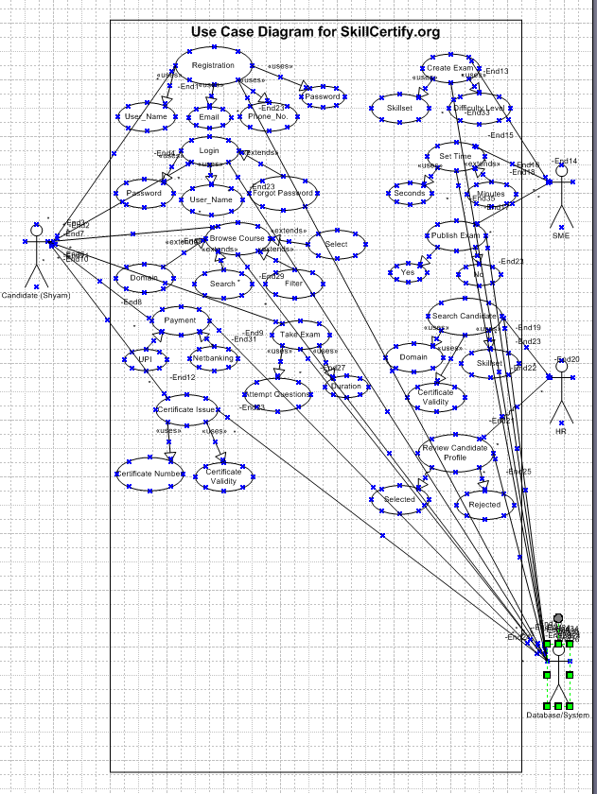

Question 11 - (Minimum 5) Use Case Specs – 15 Marks
Prepare Use Case Specifications for a minimum of 5 Use Cases from the SkillsCertify.org platform.
For each Use Case Spec, include: Use Case ID, Use Case Name, Actor(s), Pre-conditions, Main Flow (Basic Path), Alternate Flow, Exception Flow, and Post-conditions.

Answer 11:-
Example (for 5 use cases):
UC01 – Candidate Registration
- Actor: Candidate
- Pre-condition: Candidate has a valid email and access to the registration page.
- Main Flow: Candidate enters details → System validates → Account created → Confirmation email sent.
- Alternate Flow: Invalid email → Error message → Retry option.
- Exception Flow: Server error → Registration fails → Candidate notified.
- Post-condition: Candidate account successfully created and stored in the database.

UC02 – Candidate Exam Taking
- Actor: Candidate
- Pre-condition: Candidate is logged in and has selected an available exam.
- Main Flow: Candidate starts exam → Answers questions → Submits exam → System evaluates responses.
- Alternate Flow: Candidate pauses exam → System auto-saves progress → Resume later.
- Exception Flow: Internet disconnect → Exam auto-saved → Candidate notified.
- Post-condition: Exam submitted and result stored in candidate profile.

UC03 – SME Exam Creation
- Actor: SME (Subject Matter Expert)
- Pre-condition: SME is logged in and authorized to create exams.
- Main Flow: SME selects domain → Adds questions → Saves draft → Publishes exam.
- Alternate Flow: SME saves as draft → Publishes later.
- Exception Flow: Invalid question format → Error message displayed.
- Post-condition: Exam published and visible to candidates.

UC04 – HR Manager Search Certified Candidates
- Actor: HR Manager (Partner Company)
- Pre-condition: HR Manager is logged in and has access to the company portal.
- Main Flow: HR enters search criteria → System retrieves matching profiles → HR views and downloads candidate details.
- Alternate Flow: No matching candidates → System suggests similar profiles.
- Exception Flow: Database connection error → Search fails → Retry option shown.
- Post-condition: HR Manager successfully views or downloads candidate profiles.

UC05 – Notification Trigger
- Actor: System
- Pre-condition: Candidate has completed certification and results are stored.
- Main Flow: System detects new certification → Sends notification to HR Managers subscribed to that domain.
- Alternate Flow: HR Manager unsubscribed → No notification sent.
- Exception Flow: Email server down → Notification queued for retry.
Question 12 - (Minimum 5) Activity Diagrams – 15 Marks
Prepare Activity Diagrams for a minimum of 5 key workflows in the SkillsCertify.org platform.
Each diagram should clearly show the start point, decision nodes, parallel activities (where applicable), and end point.
Answer 12:- Activity Diagram:- It shows how the system is responding by using this diagram.
Candidate Registration Flow:- Candidate Login Flow:
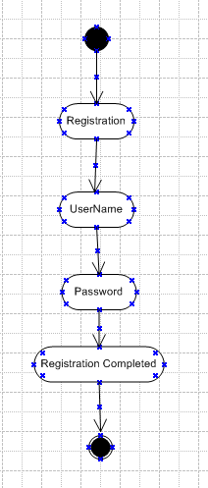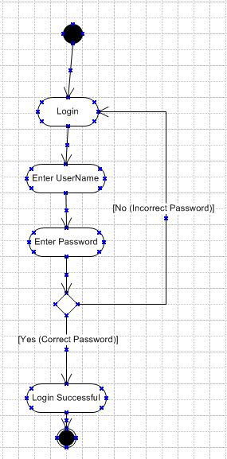

Course Payment Flow: Course Payment Confirmation:
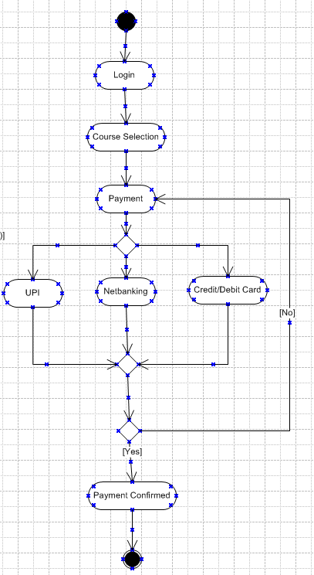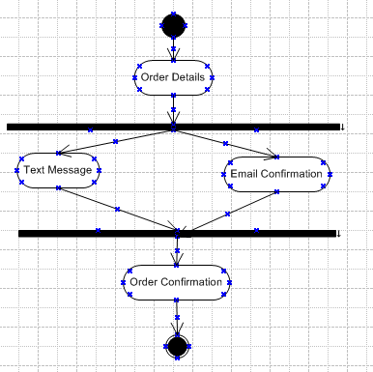
HR Manager Certificate Verification:
